Task 1: Computer Anatomy- Memory, Ports, Motherboard and add-on cards.

*Computer Anatomy*

A computer can be defined as an electronic device capable of processing the data and producing the information. The computer system essentially comprises three important parts –

1. input device

2. central processing unit (CPU)

3. output device

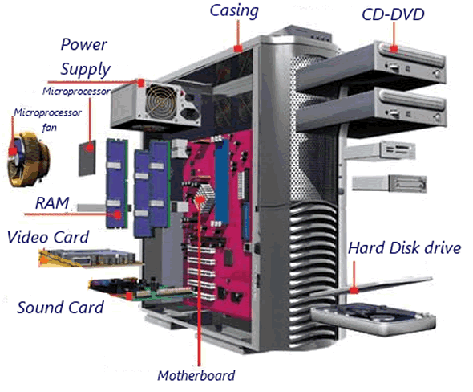

**Core Components:**

1. **Central Processing Unit (CPU)**: The brain of the computer where most calculations take place. It's responsible for executing instructions and managing tasks.

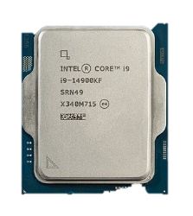

A modern consumer CPU made by [Intel](https://en.wikipedia.org/wiki/Intel): An [Intel Core i9-14900KF](https://en.wikipedia.org/wiki/Intel_Core_i9-14900KF)

*The CPU itself is made of three components namely,*

1. arithmetic logic unit (ALU),

2. memory unit, and

3. control unit.

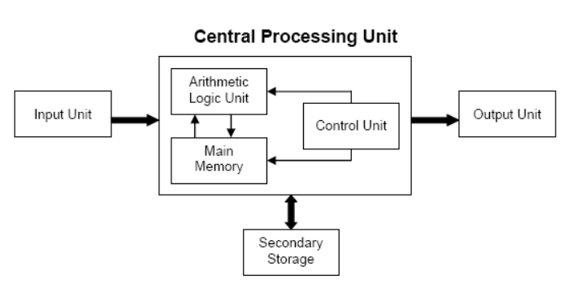

On broad basis, a computer performs the following tasks:

**Input**: Sending the data and command to the computer is known as input.

**Processing**: Work done by the computer with the help of processing hardware and software to produce results is known as processing.

**Output**: The result displayed by the computer is known as output.

**Storage**: A place to save result inside or outside the computer is known as storage.

1. **Motherboard**: The backbone that connects all the components together. It houses the CPU, RAM, and other crucial parts.

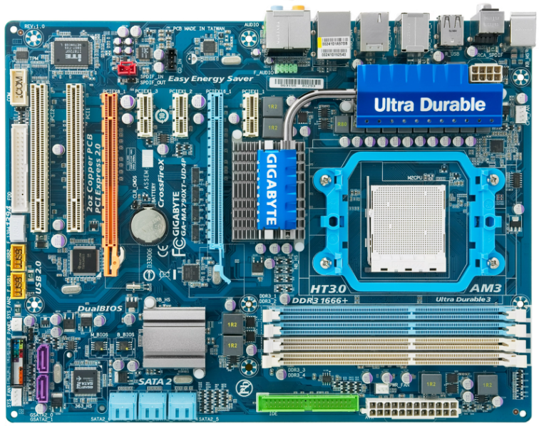

Motherboard

1. **Memory (RAM)**: Random Access Memory is the short-term memory of the computer, used for storing data that is actively being used or processed.
2. **Storage**: There are two main types:
   * **HDD (Hard Disk Drive)**: Uses magnetic storage to store and retrieve data.
   * **SSD (Solid State Drive)**: Uses flash memory for faster data access and retrieval.
3. **Power Supply Unit (PSU)**: Converts electrical energy from an outlet into a usable form for the computer. It's the heart that pumps power to every component.
4. **Graphics Processing Unit (GPU)**: Handles rendering images, videos, and animations. It's especially important for gaming, video editing, and other graphics-intensive tasks.

**Peripheral Components:**

1. **Monitor**: The screen that displays visual output from the computer.
2. **Keyboard and Mouse**: Input devices that allow you to interact with the computer.
3. **Speakers and Microphone**: Audio input and output devices for sound.

**Cooling System:**

* **Fans and Heat Sinks**: Keep the temperature down by dissipating heat generated by the CPU and GPU.

**Connectivity:**

1. **Network Interface Card (NIC)**: Connects the computer to a network (wired or wireless).
2. **USB Ports**: For connecting various peripherals like printers, external drives, and more.

**1. Memory**

* **RAM (Random Access Memory)**: RAM, or **Random Access Memory**, is a crucial component of any computer system. It provides space for your computer to read and write data to be accessed by the CPU quickly. It is volatile, meaning it loses its data when the power is turned off.

Here are the main types of RAM:

* **SRAM (Static RAM)**: This type of RAM is fast and costly. It uses flip-flops to store each bit of memory and does not need to be refreshed constantly.
* **DRAM (Dynamic RAM)**: More common and less expensive than SRAM, DRAM stores each bit of data in a separate capacitor within an integrated circuit and requires periodic refreshing.
* **SDRAM (Synchronous DRAM)**: This type synchronizes with the system clock, allowing for faster data access.
* **DDR SDRAM (Double Data Rate SDRAM)**: An advancement over SDRAM, DDR can transfer data twice per clock cycle. There are several generations of DDR, each offering increased speed and efficiency:

1. 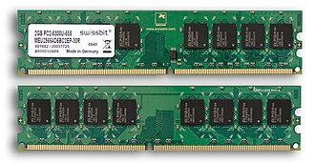DDR1
2. DDR2
3. DDR3
4. DDR4

**ROM (Read-Only Memory)**: Permanent storage that typically contains the system's firmware.It is a type of non-volatile memory used in computers and other electronic devices. Unlike RAM, which loses its data when the power is turned off, ROM retains its data permanently, even without power. This makes ROM ideal for storing firmware, which is the software that is closely tied to specific hardware and rarely needs to be updated.

Here are the main types of ROM:

1. **MROM (Masked ROM)**: The original form of ROM, MROM is programmed during the manufacturing process and cannot be altered. It's used for applications where the data or code does not need to change.
2. **PROM (Programmable ROM)**: PROM can be programmed by the user after manufacturing, but only once. This type of ROM is used for applications where customization is required, but changes are infrequent.
3. **EPROM (Erasable Programmable ROM)**: EPROM can be erased by exposing it to ultraviolet light and then reprogrammed. This provides flexibility for development and testing purposes.
4. **EEPROM (Electrically Erasable Programmable ROM)**: EEPROM can be erased and reprogrammed using electrical signals. This type of ROM allows for more convenient and frequent updates compared to EPROM. It's commonly used in devices like microcontrollers and BIOS chips.
5. **Flash Memory**: A type of EEPROM, flash memory can be erased and reprogrammed in blocks, making it faster and more efficient for larger data storage. It's widely used in SSDs, USB drives, and memory cards.

Each type of ROM has its own advantages and use cases. For example, Flash Memory is popular for its speed and capacity, while MROM is used when permanent storage with no need for updates is required.

* **Cache**: High-speed storage located close to the CPU to speed up access to frequently used data.

**2. Ports**

* **USB Ports (Universal Serial Bus)**: Used for connecting a wide range of peripherals like keyboards, mice, and external storage devices.
* **HDMI (High-Definition Multimedia Interface)**: Used for transmitting audio and video signals to monitors and TVs.
* **Ethernet Port**: For wired internet connections.
* **Audio Jacks**: For connecting headphones, microphones, and speakers.

**3. Motherboard**

* **CPU Socket**: The slot where the processor is installed. 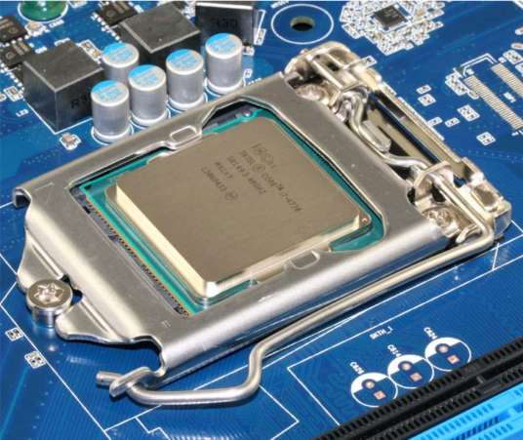
* **RAM Slots**: Where the memory modules are inserted.
* **PCIe Slots**: Expansion slots for graphics cards, sound cards, and other add-on cards.
* **Chipset**: Controls data flow between the CPU, memory, and peripherals.

**4. Add-on Cards**

* **Graphics Card (GPU)**: Handles rendering of images, video, and animations for display.
* **Sound Card**: Manages audio input and output.
* **Network Interface Card (NIC)**: Provides network connectivity.